Architectural Review Checklist

caIntegrator2 - GenePattern Integration

Version 1

Revision Document History
Date | Version | Description | Author
06/15/07 | 0.5 | First draft | NCI CBIIT Dedicated Support

Table of Contents
1. Introduction 6
1.1 Purpose 6
1.2 Guidelines for Completing the ARC 6
2. Project Details (To be answered by development team) 6
2.1 General Information 6
2.1.1 Project Description 6
2.1.2 Contact Information 7
2.1.3 Major Deployment Milestones 7
2.2 Architectural Details 7
2.2.1 High level architectural description: 7
2.2.2 High Level Design Diagram (If available): 7
2.2.3 Implementation language(s) used? 7
2.2.4 Will connections/requests to the application be session based (i.e. statefull versus stateless)? If so, is there any reason why application would not support “sticky session” load balancing? 7
2.2.5 Will the application be caching data? If so, what is being cached and how much data will be cached? 7
2.2.6 What data files will be created (if any)? How much data will be saved on an on going basis? 7
2.2.7 Will this application need a database schema(s) created on the NCICB infrastructure? If so, what is the maximum number of objects to be stored? 8
2.2.8 Are there any external/non-NCICBIIT data sources that will be accessed by the application? 8
2.2.9 If this is a web-based application, what are the preferred virtual hosts names to be registered? 8
2.2.10 Any additional architectural details that may be of significance to the needed deployment environment. 8
2.3 Performance Requirements 8
2.3.1 Total number of users for this application? 8
2.3.2 Peak number of concurrent users? 8
2.3.3 Peak number of requests/minute? 8
2.3.4 Up time requirements? 8
2.3.5 Acceptable down time when recovering from major systems disaster? 8
2.4 NCICB Project Dependencies 8
2.5 Configuration Management Details 8
2.5.1 Version Control 8
2.5.2 Change Control 8
2.5.3 Migration to CVS 8
2.5.4 Users 9
2.5.5 Build Process 9
2.5.6 Other CM Needs 9
2.6 Additional Notes 9
3. System Requirements (To be answered by both development & systems team) 9
3.1 Operating System 9
<<Solaris/LINUX/Windows 2000/…>> 10
3.2 Software (Technology Stack) 10
3.2.1 Web Server: <<Apache/Tomcat/ZOPE/…>> 10
3.2.2 App Server: <<Tomcat/JBoss/Oracle 9iAS/…>> 10
3.2.3 Database Server: <<Oracle/MySQL/PostgreSQL/…>> 10
3.2.4 Other software components: <<PERL x.x, MatLab x.x, R x.x, …>> 10
3.3 Server Hardware 10
3.3.1 Server: <<type, model, …>> 10
3.3.2 Minimum processor speed: 10
3.3.3 Minimum memory: 10
3.3.4 Minimum local drive space: 10
3.4 Storage 10
3.4.1 Expected file server disk storage (in MB): 10
3.4.2 Expected database storage (in MB): 10
3.4.3 Expected ftp storage (in MB): 10
3.4.4 Expected media/image storage (in MB): 10
3.5 Load Balancing/Fault Tolerance 10
3.5.1 Does the application support load balancing? 10
3.5.2 Implement load balancing – YES/NO 10
3.6 Networking 11
3.6.1 Any application specific port assignments? 11
3.6.2 Any additional configuration? 11
3.7 Additional Notes 11
4. Proposed NCICB Deployment Environment (To be answered by systems team) 11
4.1 Hardware 11
4.2 Technology Stack 11
4.3 File Server 11
4.4 Database 11
4.5 Networking 11
4.6 Other Resources 11
5. Impact Assessment (To be answered by systems team) 11
5.1 Overview 11
5.2 Cost 11
5.3 Timeline to implement 11
5.4 Additional Notes 12
6. Acceptance 12
7. Appendix 1 - Future Systems Requirements 13
7.1 New Architecture Diagram 13
7.2 Notes on the design change 13
7.3 Hardware 13
7.3.1 Servers 13
7.3.2 Processor speed 13
7.3.3 Memory 13
7.3.4 Drive Space 13
7.4 Software (Technology Stack) 13
7.4.1 Web Server 13
7.4.2 App Server 13
7.4.3 Other components 13
7.5 Fault Tolerance (Redundancy) 13
7.5.1 Does the application support load balancing? 13
7.5.2 Implement load balancing – YES/NO 13
7.5.3 Load balancing requirements 13
7.5.4 Fault tolerance solution suggested 13
7.5.5 Additional requirements (if any) 13
7.6 Performance Enhancements 13
7.6.1 Processing Power 13
7.6.2 Memory 13
7.6.3 I/O 13
7.6.4 Other needs 13

Introduction

Purpose
The purpose of the Architectural Review Checklist (ARC) is to help identify the deployment environment (both hardware and software components) necessary for an application to execute optimally within the NCI CBIIT IT infrastructure. The ARC is considered to be a dynamic artifact for any NCI CBIIT project and should be maintained in the configuration library (i.e. CVS) for each project. For new projects, this document template will be automatically checked into the projects repository by the SCM team upon project initiation. The ARC should be reviewed on at least a quarterly basis to capture any application design changes that may effect the deployment environment necessary for optimal performance.

Guidelines for Completing the ARC
The ARC is divided into 4 main sections. The first section (Project Details) is meant to capture general information about the project. The project development team should fill out the Project Details section and return it to the systems team. The second section (Systems Requirements) is meant to capture details of specific system requirements for the project. Both the development and system teams will preferably answer the Systems Requirement section jointly. However, depending on the development team’s familiarity with the NCI CBIIT infrastructure, they may choose to answer either all or parts of this section on their own. The third section (Planned Deployment Environment) specifies the proposed deployment environment for the application and is to be answered by the systems team based on the response to section 1 & 2. Finally, the last section (Impact Assessment) describes the impact (additional hardware/software costs, staffing resources…) to the existing NCI CBIIT IT infrastructure in order to support this application. Upon completion of the Deployment Environment and Impact Assessment sections, the systems team will return the ARC to the development team for final review and comments.

Project Details (To be answered by development team)

General Information

Project Description
The caIntegrator2 is caBIG’s next generation of translational informatics application. This application would allow users of the system to configure new studies and update existing studies in support of translational research needs. Once configured, the application will allow end users to browse, analyze and store results. Where appropriate, the application will enable data sharing via caBIG APIs and/or grid services. The caIntegrator2 is planned to function similar to existing caIntegrator applications. The major difference will be that there is not a separate data-portal for different studies.

CaIntegrator2 is designed to support any installation of GenePattern. But in order to support the development activities of caIntegrator2 and for future integration of caIntegrator2 for NCI hosted apps, a stand-alone GenePattern is required to be installed.

Contact Information
Title | Name | Phone | Email
Product Manager | Anand Basu | (301) 437-4165 | basuan@mail.nih.gov
Project Manager | Shine Jacob | (301)443- 6856 | Jacobss2@mail.nih.gov
Architect | Eric Tavela | 301) 451- 6357 | Tavelae@mail.nih.gov
Tech Lead | JP Marple | (301) 443- 6025 | marplej@mail.nih.gov

Major Deployment Milestones
Milestone | Date
Planned Release to QA | Apr 2009
Planned Release to Staging | Apr 2009
Planned Release to Production | Sep 2009

Architectural Details

High level architectural description:

- The Genepattern server is a product of the Broad Institute at MIT. It provides extensive set of modules for the analysis and visualization of genomic data (http://www.broad.mit.edu/cancer/software/genepattern/) The Genepattern server will complement the caIntegrator2 by providing a large number of analysis and visualization modules.

High Level Design Diagram (If available):
A high level diagram is shown below – as described in GenePattern documentation.
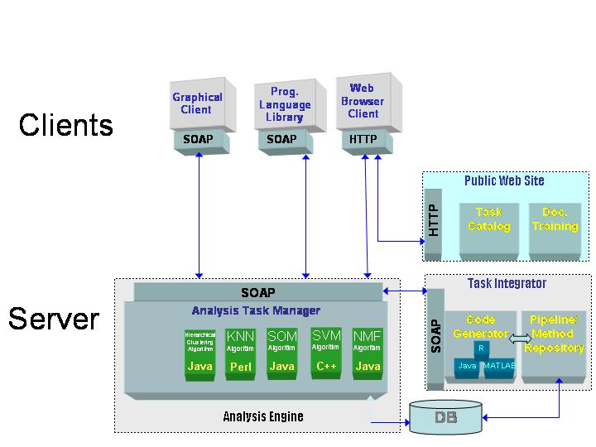

caIntegrator2 will be also using a grid installation of GenePattern. A high-level architecture diagram for this is shown below.

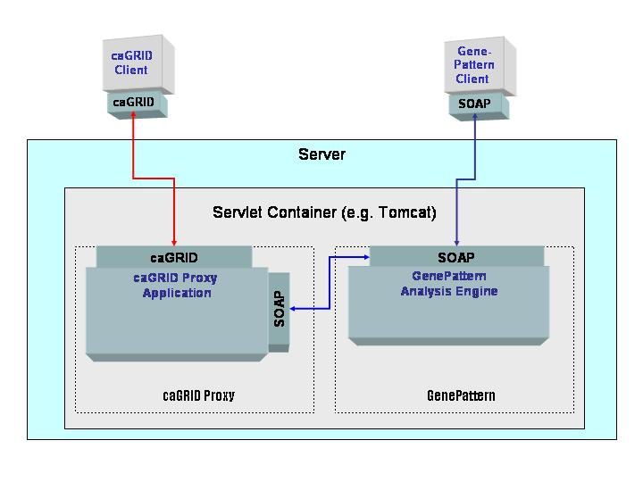

More technical implementation is outlined in the document located at
https://gforge.nci.nih.gov/plugins/scmsvn/viewcvs.php/*checkout*/trunk/genepattern/cabig_ey2_2008/PCA_GN/documentation/silver_compatibility_pca/PCA_TechnicalGuide.doc?root=genepattern&rev=606
Also, please refer to caIntegrator2 ARC document for details on how caIntegrator2 will be using GenePattern.
https://gforge.nci.nih.gov/svnroot/caintegrator2/trunk/docs/deployment/caIntegrator2%20Architectural%20Review%20Checklist.doc

Implementation language(s) used?

This will be an installation of GenePattern. There will not be any specific development on this server.

Will connections/requests to the application be session based (i.e. statefull versus stateless)? If so, is there any reason why application would not support “sticky session” load balancing?
User state is maintained in the Genepattern server as well as in the caIntegrator2.

Will the application be caching data? If so, what is being cached and how much data will be cached?
Genepattern stores the results of compute runs for future reference. The amount of the data will depend on investigator usage of the system. Genepattern has a mechanism for removing compute results after a given time period. We believe the default time period is one week.

What data files will be created (if any)? How much data will be saved on an on going basis?
Again this will depend on the system usage. The results of compute runs will be stored for some period of time and then removed. Unlike existing caIntegrator applications, caIntegrator2 do NOT keep the Rbinary files or any other pre-computed data on this server.

10GB of storage is sufficient based on current needs.

Will this application need a database schema(s) created on the NCICB infrastructure? If so, what is the maximum number of objects to be stored? No

Are there any external/non-NCICB data sources that will be accessed by the application?
Link to affymetrix or other platform provider site, but no run time data retrieval

If this is a web-based application, what are the preferred virtual hosts names to be registered?

caintegrator2-gp-dev.nci.nih.gov - for development.
caintegrator2-gp.nci.nih.gov - for Prod .

The plan is to have the Genepattern server only be accessable by going through a caIntgrator2 application. For example, the user would log into caIntegrator2 and then from within a into caIntegrator2 study link over to Genepattern. We do not plan to have the Genepattern server accessible without going through caIntegratior2.

Any additional architectural details that may be of significance to the needed deployment environment.
Genepattern grid modules should be loaded to GenePattern. In-order to accomplish this, refer to Chapter 3 – GenePattern Grid Extensions – Install Modules. For caIntegrator2, GISTIC Module is required to be installed.

Performance Requirements

Total number of users for this application? 300+

Peak number of concurrent users? 100+

Peak number of requests/minute?

Up time requirements? Ideally 24/7, but weekend/late evening (EST) maintenances are acceptable

Acceptable down time when recovering from major systems disaster? Within 24 hrs

NCI CBIIT Project Dependencies

Configuration Management Details
Briefly describe your current configuration management practices here.

Version Control
What version control software are you currently using, if any?
SVN

Change Control
What are your current change control practices? What procedures are in place to determine whether to implement a change request?
After Customer Approval, Changes are deployed on QA for testing. Next forwarded to
Staging and then to Production.

Migration to CVS
Indicate whether you will require SCM support migrating your source code to the NCICBIIT CVS repository.
no

Users
Provide a list of all developers who require access to your repository modules.
JP Marple
Eric Tavela
Huaitian Lu
Will Fitzhugh
Shine Jacob
Ngoc Nguyen
TJ Andrews

Build Process
Describe your build process here. For example, are you using Ant, Make, or something else?
We do not plan to build the Genepattern server from source at the current time. The Genepattern server can be built from source using Ant.

Other CM Needs
Describe any other CM needs?

Additional Notes

At this time we are aware that for the grid installation of GenePattern, the following pre-requisites are required
- Install Apache Ant 1.6.5,
- Install caGrid 2.0,
- Install A Java SDK 1.5.x:

System Requirements (To be answered by both development & systems team)

Operating System
GenePattern installers are available for Linux. GenePattern should work with operating system that has a Java 1.5 virtual machine installed. GenePattern is known to work on the following OS platforms:

Linux SuSE, Red Hat, Mandrake
Other Unix Solaris, AIX, Tru64

Users are also running GenePattern on the Debian, Fedora, and Gentoo distributions of Linux.

Software (Technology Stack)

Web Server:

App Server:

Database Server:

Other software components:

Server Hardware

Server:

Minimum processor speed: Not exactly sure, some of the Genepattern jobs can be quite compute intensive. In general the Genepattern jobs are more compute intensive than the current analysis server jobs.

Minimum memory: 2GB

Minimum local drive space: Estimate 10 Gig of space .

Storage

Expected file server disk storage (in MB):Estimate 10 Gig

Expected database storage (in MB): NA

Expected ftp storage (in MB): NA

Expected media/image storage (in MB) NA

Load Balancing/Fault Tolerance

Does the application support load balancing? Not sure, never tested it

Implement load balancing – YES/NO, No problems if we can test it on staging first

Networking

Any application specific port assignments? caIntegratorApps need to know what URL to use to connect to the Genepattern server. The systems team can assign the port numbers and communicate the information to the development team.

Any additional configuration? CSM and LDAP

Additional Notes
The GenePattern Web Client has been tested on the following browsers:
Platform Browsers
Windows MS Internet Explorer 6.0.2800 and 7.0, Firefox 2.0
Mac Safari, Firefox 2.0
Linux Firefox 2.0

Proposed NCICB Deployment Environment (To be answered by systems team)

Hardware
<<dev, qa, staging, production servers to be used>>

Technology Stack
<<specific technology stack to be used>>

File Server
<<space allocation on big IP, NFS mount points, initial size allocation…>>

Database
<<database server to used, schema names to be created, initial size, maximum size…>>

Networking
<<e.g. any BigIP configuration necessary, …>>

Other Resources
<<e.g. ftp server access, media server access, …>>

Impact Assessment (To be answered by systems team)

Overview

Cost

Timeline to implement

Additional Notes

Acceptance
Project Lead ( ) | Project Coordinator – NCICB ( )
Systems Team | SCM Administrator

Appendix 1 - Future Systems Requirements
New studies will need additional resources (disk and cpu) .

New Architecture Diagram

Notes on the design change

Hardware

Servers

Processor speed

Memory

Drive Space

Software (Technology Stack)

Web Server

App Server

Other components

Fault Tolerance (Redundancy)

Does the application support load balancing?

Implement load balancing – YES/NO

Load balancing requirements

Fault tolerance solution suggested

Additional requirements (if any)

Performance Enhancements

Processing Power

Memory

I/O

Other needs

